Proceedings of the International Laser Technology Congress AKL´10

Finalists of the Innovation Award Laser Technology 2010

Q-switched INNOSLAB lasers for high quality micro-processing

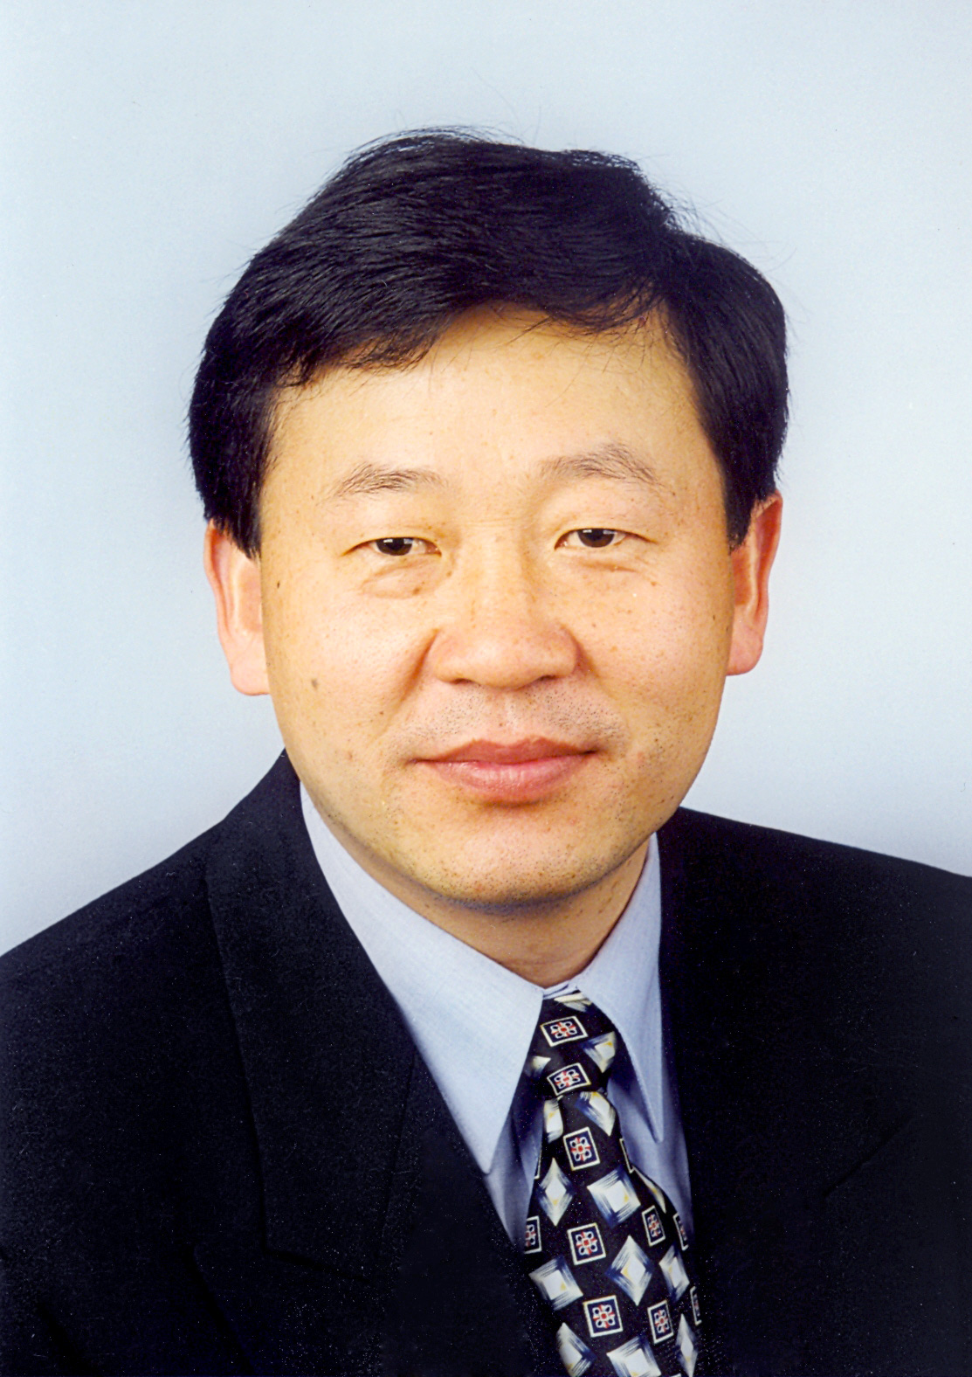

Dr. rer. nat. Keming Du

Team Representative:

Dr. rer.nat. Keming Du
Managing Director
EdgeWave GmbH
Würselen

Members of the project management team:
Dr. rer. nat. Keming Du, Managing Director, EdgeWave GmbH, Würselen
Dr. Daijun Li, Manager Optics, EdgeWave GmbH, Würselen
Dipl.-Ing. Alexander Schell, Manager Electronics, EdgeWave GmbH, Würselen
Dr. Claus-Rüdiger Haas, Manager Production, EdgeWave GmbH, Würselen

Areas of application
Major sectors of industry which are profiting from the INNOSLAB technology are:
- Photovoltaics, e.g. scribing, drilling and cutting of Si-wafer, glass drilling, ablation of conduction or dielectric layers of thin film solar and crystalline Si solar cells
- Display industry, e.g. structuring of conduction layers, sequential lateral crystallization of Si, cutting and drilling of glass
- Glass industry, e.g. micro drilling, cutting and high throughput subsurface engraving
- Scientific instruments industry, e.g. pumping of dye lasers, pumping of OPO and Ti:Saphire lasers, particle imaging velocimetry
- Electronics industry, e.g. drilling and cutting of printed circuit boards, scribing and dicing
- Tool making industry and mechanical engineering, e.g. 3D rapid prototyping

Technological impact
- improving existing manufacturing processes
- enabling new production processes and new types of products
- precision processing with small heat affected zones and high reproducibility
- high productivity in micro-processing
- new design of drilled holes by changing the cross-sections along the hole depth
- green processing with high energy efficiency
- efficient pumping sources for dye lasers, OPO and OPA sources at high repetition rates

Abstract
INNOSLAB lasers represent a new laser class which is suitable for a large variety of applications in different sectors of industry and research. A q-switched INNOSLAB laser combines the following elements:
- A slab-shaped laser crystal with only two polished end faces for passing the pump radiation and the resulting laser beam and with two large faces for contact cooling
- Partial pumping of the slab crystal with diode laser stacks
- Use of a hybrid resonator for diffraction-limited beam quality at high efficiency
- A slab shaped Pockel-cell and a polarizer as q-switcher

The optimal combination of crystal shape, cooling, resonator design and efficient beam shaping is the origin of a unique set of favourable features of INNOSLAB lasers:
- Short pulse duration and high peak output
- High beam quality and flexibility in beam profile
- High pulse energy at high pulse repetition rate
- Scalability at high performances
- High efficiency at high average power
- Compact design with high reliability

The parameter field of current INNOSLAB lasers is:
- beam quality: M² < 2
- pulse energy up to 60mJ
- pulse length down to 4ns
- peak power up to 7MW
- pulse rep. rate up to 100 kHz
- average power up to 600W
- wavelength 1064, 532, 355, 266nm

With these features INNOSLAB lasers enable a variety of challenging applications with added value such micro-processing of glass, scribing, edge deletion, high throughput thin film structuring, and pumping of dye lasers. Many sectors of industry such as photovoltaics, electronics, display and glass industry, mechanical engineering and tool making industry are profiting from the INNOSLAB technology.

1. High power and high pulse energy INNOSLAB lasers
(Photo: EdgeWave GmbH, Würselen)

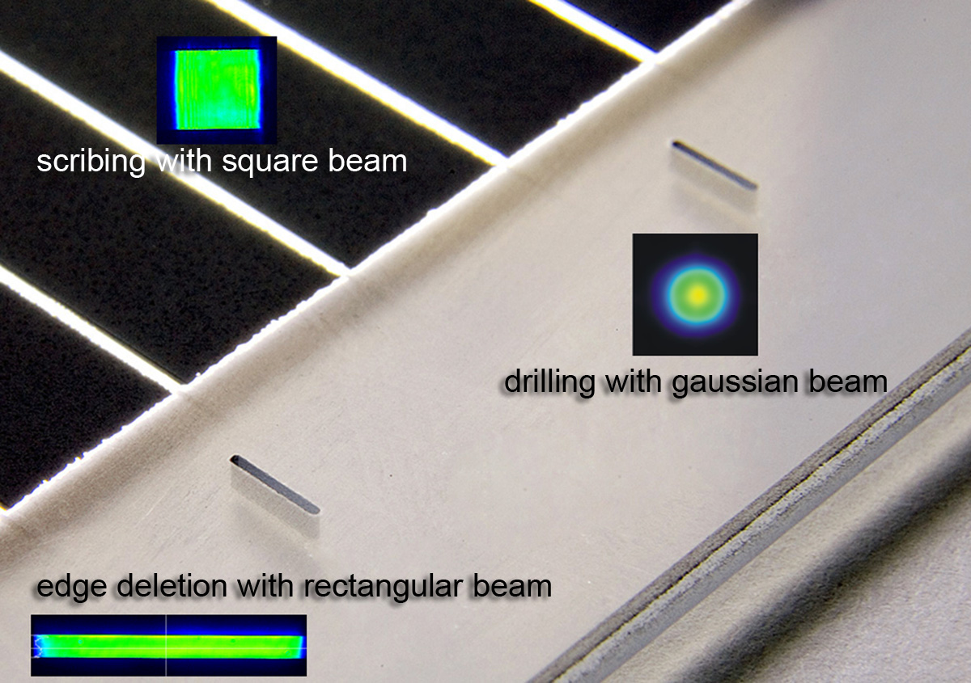

2. Thin film solar processing with INNOSLAB lasers
(Photo: EdgeWave GmbH, Würselen)

