Proceedings of the International Laser Technology Congress AKL´10

Finalists of the Innovation Award Laser Technology 2010

Laser hybrid welding of thick sheet metals with disk lasers in shipbuilding industry

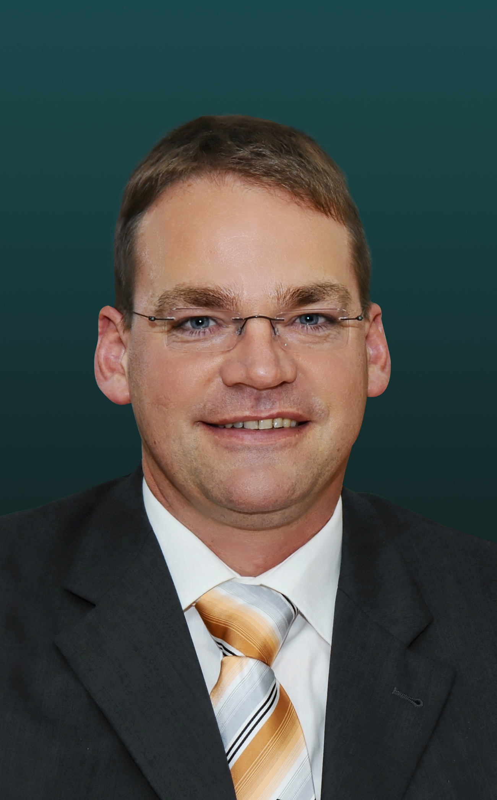
Dipl.-Ing. Hermann Lembeck

Team Representative:

Dipl.-Ing. Hermann Lembeck
MEYER WERFT Laserzentrum GmbH
Papenburg

Members of the project management team:
Dipl.-Ing. Hermann Lembeck, Factory manager
Dipl.-Ing. Guido Pethan, Project leader invests
Dipl.-Ing Frank Boekhoff, Test manager, R&D
MEYER WERFT Laserzentrum GmbH, Papenburg

Area of application
- Shipbuilding

Technological impact
- Reduced manufacturing costs by less distortion and thus less rework compared to conventional welds and by using more automated welding systems
- Reduction of block joints up to 30% per ship by the new ability to build blocks with a length of 30 m with a 50% wider panel line
- optimal balance between reducing weight and achieving the required strength
- New product features by using different plate thicknesses and thus more freedom regarding the construction of the ship
- Improved quality assurance by an adaptive seam tracking system combined with a control of filling degree
- The Laser-GMA-Hybrid-Welding with disc lasers leads to a higher electrical efficiency and thus to less energy consumption compared to CO₂-Laser-Welding
- Higher production versatility by using disc lasers with fibres instead of CO₂-lasers with guiding mirrors

Abstract
The shipbuilding industry, especially the cruise ship market, is affected by the pressure to reduce the weight of a ship in order to reduce fuel consumption and to improve the environment. Alternatively the weight of the ship can be kept and the number of decks concurrently raised to increase the passenger capacity. In both cases the CO₂-emission in relation to one passenger decreases. Currently shipbuilding sections with a plate thickness of at least 5 mm and a maximum length of 20 m can be constructed at the MEYER WERFT Laserzentrum GmbH. When the first panel line was put into operation in 1999, just CO₂-lasers with enough power for shipbuilding applications were available. To guide the beams with a wavelength of 10,6 micrometers cupper mirrors have to be used. Due to the beam divergence the maximum welding length is limited to 20 m. Consequently there is a block joint of each 20 m of the length of a ship. Thus the heat input is quite high, because block joints are welded with conventional welding procedures. In this case the costs of reconditioning are very high. Furthermore the handling technology for the prefabricated parts is complex and time-consuming.

In order to minimize the weight of the ship, Tailored Design will now be applied at MEYER WERFT Laserzentrum GmbH. Thereby the liberty is given to use thinner plates at those parts of the deck where strength requirements are permitting. Thus plates with a thickness of 3 mm minimum will be used in coming ship constructions. In order to create high-quality-welds at these thin plates an innovative and effective one-side-welding machine is needed. Because the beam quality of the applied laser source has a large influence on the welding technology disc lasers were selected for the challenging requirements. They generate the welding quality that is needed to apply Tailored Blanks in shipbuilding. By using different thicknesses at one section it is possible to achieve an optimal balance between reducing the weight and achieving the required strength. There is more freedom regarding the construction of the ship by using different plate thicknesses. Customer demands, which could not be implemented in the past, will be realistic now.

In order to reduce the number of block joints in the building dock by fabricating longer blocks, the panels in the prefabrication shop have to be longer too. By using the disc laser welding technology the maximum block length will be raised in the new panel line up to 30 m and thus by 50%. An adaptive seam tracking system is installed to improve the quality of the welds. This system will be combined with a control of filling degree in order to minimize the heat input. This leads to less distortion, less energy consumption and less reworking. The use of light cables with disc lasers generates higher production versatility, very useful for ever growing panels of cruise ships.

The savings directly resulting by the lower processing time and higher efficiency are evident. But the main savings are created by the cost savings in succeeding production steps because with less conventional welds also less deformation can be expected. Less rework must be performed and less floor balance mass must be applied. Besides this fewer alignments have to be carried out, when the blocks are put on the building shell in the dock. In fact the production gets more precise by using automated welding systems. Thereby complete working steps in the production process can be saved.

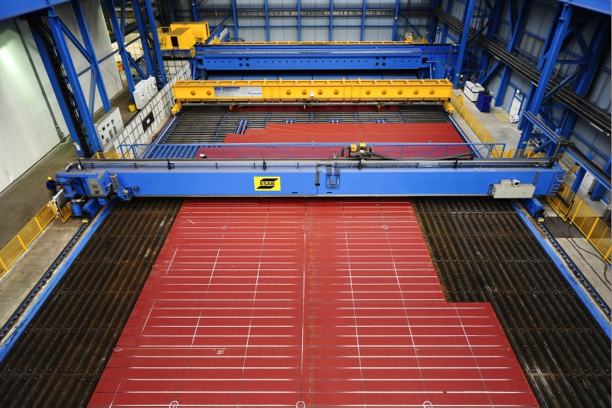

1. View on the new one-side-welding station, on which panels by a size up to
30 x 25m are constructed
(Photo: MEYER WERFT Laserzentrum GmbH, Papenburg)

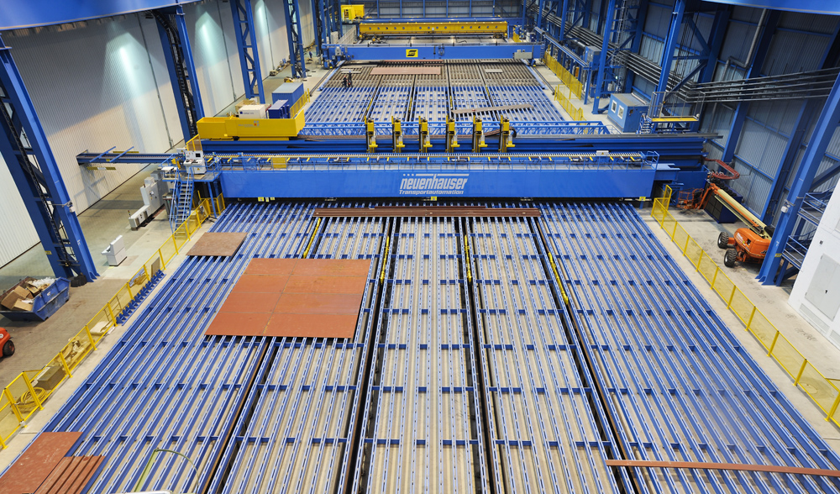

2. Automated systems of the new panel line of MEYER WERFT at one view.
(Photo: MEYER WERFT Laserzentrum GmbH, Papenburg)

