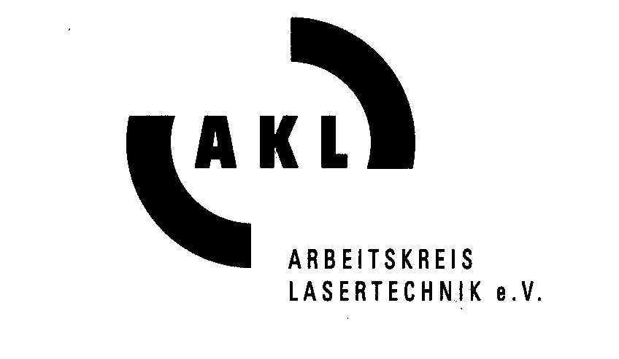

PRESS RELEASE Aachen, 5th May 2010

Dr. rer. nat. Keming Du, managing director of EdgeWave GmbH:

Prize Winner of the Innovation Award Laser Technology 2010

The Innovation Award Laser Technology 2010, initiated by the associations Arbeitskreis Lasertechnik e.V. and the European Laser Institute ELI and provided with 10 000 Euros prize money, has been conferred to Dr. rer. nat. Keming Du, managing director of EdgeWave GmbH, Würselen, Germany on 5th May 2010 in Aachen´s town hall. Dr. rer. nat. Keming Du has applied to the open call for proposals with the innovation “Q-switched INNOSLAB lasers for high quality micro-processing”. In the historical ambience of the »Coronation Hall« over 250 guests of the 500 participants of the International Laser Technology Congress AKL´10 attended the awarding ceremony.

Prof. Reinhart Poprawe, vice-president of the association Arbeitskreis Lasertechnik AKL e.V. and director of the Fraunhofer Institute for Laser Technology ILT, welcomed in Aachen´s town hall the audience and especially the teams of the 3 finalists and the 10 members of the international jury. In his laudatio Dr. Paul Hilton from The Welding Institute TWI Cambridge and speaker of the jury members pointed out the dedicated work of all 3 finalist´s and the outstanding innovations of the project teams in the field of laser technology. Prof. Dr.-Ing. habil. Prof. e. h. mult. Dr. h. c. mult. Hans-Jörg Bullinger, president of the Fraunhofer-Gesellschaft and dinner speaker of the awarding ceremony, conferred the 1st prize of the Innovation Award Laser Technology 2010 provided with 10 000 Euro prize money to Dr. Keming Du and his team of the EdgeWave GmbH, Würselen, Germany for the development of
Q-switched INNOSLAB lasers for high quality micro-processing. The prize winner Dr. Du has been furthermore awarded the title of »AKL Fellow« and »ELI Fellow«. The trophy for the prize winner and the certificates for Dr. Du and the other project management team members Dr. Claus-Rüdiger Haas, Dipl.-Ing. Alexander Schell, and Dr. Dailjun Li were handed over by Dipl.-Ing. Ulrich Berners, president of the Arbeitskreis Lasertechnik AKL e.V. and Dr. Stefan Kaierle, president of the European Laser Institute ELI.

INNOSLAB lasers represent a new laser class which is suitable for a large variety of applications in different sectors of industry and research. With his features INNOSLAB lasers enable a variety of challenging applications with added value such micro-processing of glass, scribing, edge deletion, high throughput thin film structuring, and pumping of dye lasers.

The technological impact of the innovation includes
- improving existing manufacturing processes
- enabling new production processes and new types of products
- precision processing with small heat affected zones and high reproducibility
- high productivity in micro-processing
- new design of drilled holes by changing the cross-sections along the hole depth
- green processing with high energy efficiency
- efficient pumping sources for dye lasers, OPO and OPA sources at high repetition rates

The major sectors of industry which are profiting from the INNOSLAB lasers are:
- Photovoltaic, e.g. scribing, drilling and cutting of Si-wafer, ablation of conduction or dielectric layers of thin film solar and crystalline Si solar cells
- Display, e.g. structuring of conduction layer, sequential lateral crystallization of Si
- Glass industry, e.g. micro drilling and high throughput subsurface engraving
- Scientific, e.g. pumping of dye laser, pumping of OPO and Ti:Saphire laser, particle imaging velocimetry
- Electronics industry, e.g. drilling and cutting of printed circuit boards
- Tool making and mechanical engineering, e.g. 3D rapid prototyping via ablation

The international jury selected on a basis of merit and according to the published assessment criteria (see www.innovation-award-laser.org) 2 other innovation teams as finalists, which have also been honoured in the Coronation Hall.

The prize for the 2nd place of the Innovation Award Laser Technology 2010 has been conferred to Dipl.-Ing. Jürgen Dupré and his team of Rolls-Royce Deutschland Ltd. & Co. KG, Dahlewitz and Oberursel, Germany. The innovation consists in a New repair technique for aero-engine components using Laser Metal Deposition.
The members of the project management team are:
Dipl.-Ing. Jürgen Dupré, Repair Engineering Specialist, IPT Lead
Rolls-Royce Deutschland Ltd. & Co. KG, Dahlewitz
Certified Engineer Elke Weiss, Repair Engineer
Rolls-Royce Deutschland Ltd. & Co. KG, Oberursel
Dipl.-Ing. Gerhard Backes, Project Leader Repair Processes
Lehrstuhl für Lasertechnik LLT, RWTH Aachen University
Dr. Andres Gasser, Group Leader Laser Metal Deposition
Fraunhofer-Institut für Lasertechnik ILT, Aachen

The prize for the 3rd place of the Innovation Award Laser Technology 2010 has been conferred to Dipl.-Ing. Hermann Lembeck and his team of the MEYER WERFT Laserzentrum GmbH, Papenburg, Germany. The innovation consists in Laser hybrid welding of thick sheet metals with disk lasers in shipbuilding industry
The members of the project management team are:
Dipl.-Ing. Hermann Lembeck, Factory manager
Dipl.-Ing. Guido Pethan, Project leader invests
Dipl.-Ing Frank Boekhoff, Test manager, R&D
MEYER WERFT Laserzentrum GmbH, Papenburg

All 3 applications have led to an outstanding innovation in the field of laser technology and are presented in detail including texts and photos on
www.innovation-award-laser.org.

The Innovation Award Laser Technology is a European research prize awarded at 2-yearly intervals by the associations Arbeitskreis Lasertechnik e.V. and the European Laser Institute ELI. The award can be conferred on an individual researcher or on an entire project group, whose exceptional skills and dedicated work have led to an outstanding innovation in the field of laser technology. The scientific and technological projects in question must center on the use of laser light in materials processing and the methods of producing such light, and must furthermore be of demonstrable commercial value to industry.

The international jury is consisting of 10 members that are recruited from industry and the research community. The jury’s decision was based principally on the following criteria:
• Proven commercial benefit
• Innovative quality of the resulting laser beam source, laser manufacturing process
or laser system
• Scientific / technological quality of the underlying research
• Creative approach to technology demonstrated by the designated individual or
project group
• Importance of the contribution of the applicant’s work to the overall innovative
process

Arbeitskreis Lasertechnik AKL e.V.
Arbeitskreis Lasertechnik AKL e.V. is a registered non-profit association formed in 1990 by a group of companies and private individuals aiming to pool their experience and conduct joint public-relations activities in order to spread the use of laser technology in industry and promote the sharing of scientific ideas. The »Innovation Award Laser Technology« aims to reward excellent achievements in applied research and outstanding innovation in the field of laser technology and to shine a spotlight on their authors. In 2009, around 90 laser experts and enthusiasts were signed up as active members of the AKL network. The association’s activities include disseminating information on innovations in laser technology, organizing
conferences and seminars, compiling educational material dealing with laser technology, stimulating the interest of future young scientists, and providing advice to industry and research scientists on questions relating to laser technology. More information: www.akl-ev.de

European Laser Institute ELI e.V.
Optical technology is taking an increasing hold on all domains of industry and science. Europe already possesses a strong position in this field by virtue of its numerous experts and excellent research and development facilities. Nevertheless, it has been realized that there is an urgent need to link the existing sources of know-how and expertise, and to enhance the performance of joint research activities.
Consequently, the European Laser Institute (ELI) has created an efficient platform bringing together the necessary competence and knowledge on optical technologies. By promoting technology transfer within Europe, ELI aims to enhance the international lead of European industry and research in the field of laser technology and photonics. By working in close collaboration with existing national and international organizations, the ELI network of industrial and academic research institutions helps to influence R&D policy on a national and European level. More information: www.europeanlaserinstitute.org

Further information:
- Regarding the award and the finalists: www.innovation-award-laser.org
- Regarding the Arbeitskreis Lasertechnik AKL e.V.: www.akl-ev.de
Contact person: Axel Bauer, General Secretary of Arbeitskreis Lasertechnik e.V., Phone: +49/241/8906-194, Mobile: +49/170/3309769, Fax: +49/241/8906-112,
email: axel.bauer@akl-ev.de
- Regarding the European Laser Institute ELI: www.europeanlaserinstitute.org
Contact person: Dr. Stefan Kaierle, President of the European Laser Institute,
Phone: +49/241/8906-212, Fax: +49/241/8906-121
email: kaierle@europeanlaserinstitute.org
- Regarding the International Laser Technology Congress AKL´10 (May 5-7):
www.lasercongress.org
Contact persons: Axel Bauer, Silke Boehr, Marketing and Communications,
Fraunhofer Institute for Laser Technology ILT, www.ilt.fraunhofer.de
Phone: +49/241/8906-0, Fax: +49/241/8906-121, email: info@ilt.fraunhofer.de

